**FRIO COUNTY COMMISSIONERS COURT MINUTES FOR**

**Special called Meeting February 27th, 2025**

On the 27th day of February, 2025, at 3:00 p.m., the Commissioners Court of Frio County met in a special called meeting with the following members either absent or present, to-wit: Rochelle Lozano Camacho, Frio County Judge was present; Joe Vela, Commissioner Pct 1 present; Mario Martinez, Commissioner Pct 2 present; Raul Carrizales, Commissioner Pct 3 present; Danny Cano, Commissioner Pct 4 present; Joseph A. Sindon, Legal Counsel for Frio County Commissioners Court present; and Aaron Ibarra, Frio County Clerk present when the following meeting was held, to-wit: The meeting can be seen unedited and to its full extent on our county website, under the County Clerk tab.

I. Invocation and Pledge of Allegiance

II. Adopt Agenda

**MOTION: COMMISSIONER CARRIZALES**

**SECOND: COMMISSIONER CANO**

**MOTION PASSES**

III. Old Business

**PRESENTATION**

**ACTION AGENDA ITEMS**

IV. General Discussion

V. Citizens To Be Heard

VI. New Business

**PRESENTATION**

(1) Ronald Rocha, Attorney at Law, Linebarger Goggan Blair & Sampson, LLP**,** requests:

Update on the delinquent fines and collection services by Linebarger Goggan Blair & Sampson LLP.

(2) Frio County Commissioners Court, requests:

Presentation of monthly statistics reports compiled by Allegiance.

(3) Robert Carter, requests:

Present Frio County Juvenile Probation Office audited financial statements for fiscal year 2023-2024.

**ACTION AGENDA ITEMS**

(1) Mona Hoyle, Frio County Pioneer Jail Museum Association, requests:

Consider/take action to waive the fee for Fireman’s Park rental for the Frio County Pioneer Day on March 22, 2025.

**MOTION: COMMISSIONER CARRIZALES**

**SECOND: COMMISSIONER MARTINEZ**

**MOTION PASSES**

(2) Hon. Aaron Ibarra, Frio County Clerk, requests:

Consider/take action on approving the minutes for the Frio County Commissioners Court held on January 2, 14, and 28, 2025.

**MOTION: COMMISSIONER CARRIZALES**

**SECOND: COMMISSIONER MARTINEZ**

**MOTION PASSES**

(3) Ancelmo Ornelas, Frio County Road and Bridge Administrator, requests:

3.1 Consider/take action on approving a credit application with the McGee Company.

3.2 If the application is approved, consider/take action on approving a resolution authorizing Hon. Rochelle Camacho, Frio County Judge to sign same on behalf of Frio County.

**MOTION: COMMISSIONER CARRIZALES**

**SECOND: COMMISSIONER MARTINEZ**

**MOTION PASSES**

(4) Ancelmo Ornelas, Frio County Road and Bridge Administrator, requests:

Consider/take action on approving Quote #40380887-00 for the purchase of (1) MAXX80E220 tire changer machine for $9,263.88 & (1) wheel balance machine for $7,969.13 for total cost of $17,233.01.

**MOTION: COMMISSIONER CARRIZALES**

**SECOND: COMMISSIONER MARTINEZ**

**MOTION PASSES**

(5) Ancelmo Ornelas, Frio County Road and Bridge Administrator, requests:

Consider/take action on accepting Memorandum of Donation letter for 8,000 cubic yards reclaimed asphalt pavement material (RAP) from TxDOT for maintenance on various county roads.  Material is located off Exit 104, Pearsall Texas.

**MOTION: COMMISSIONER MARTINEZ**

**SECOND: COMMISSIONER CANO**

**MOTION PASSES**

(6) Anthony Gonzales, Frio County Road and Bridge Supervisor, requests:

Discuss/approve to add a listing to our current Septic Application of licensed installers and professional engineers in our surrounding area.

**MOTION: COMMISSIONER CARRIZALES**

**SECOND: COMMISSIONER CANO**

**MOTION PASSES**

(7) Hon. Crystal Marquez, Frio County Auditor, requests:

7.1 Consider/take action on approving the Security Light Agreement with Medina Electric Cooperative Inc. for construction costs of $1,587.54 to install one street light, including scheduled lighting rate for $16.25 per month on CR 4600 in Dilley, Texas.

7.2 If the agreement is approved, consider / take action on approving and signing resolution authorizing Hon. Judge Rochelle Camacho to enter into same on behalf of Frio County.

**MOTION: COMMISSIONER CANO**

**SECOND: COMMISSIONER MARTINEZ**

**MOTION PASSES**

(8) Hon. Crystal Marquez, Frio County Auditor, requests:

8.1 Consider / take action to approve the budget amendments to the FISCAL YEAR 2024-2025 Frio County Budget, list below:

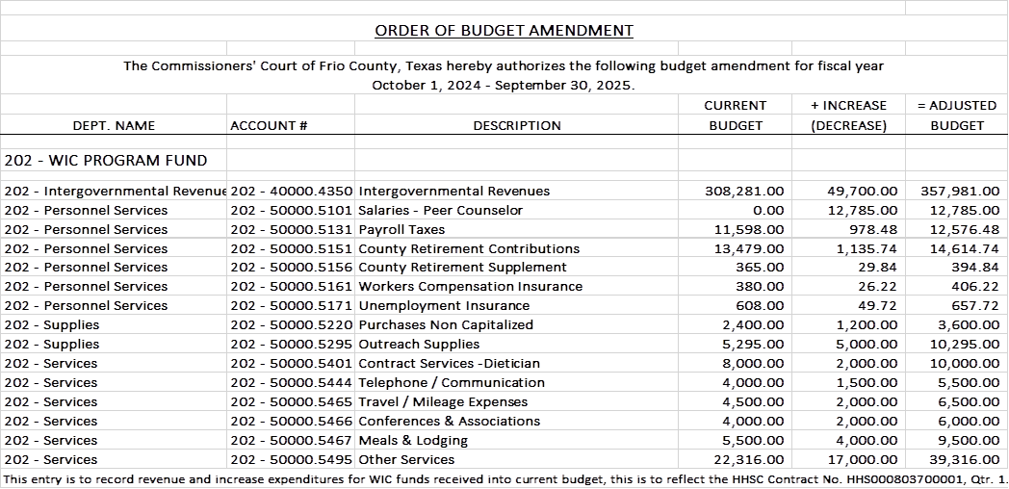

8.2 If the amendment is approved, consider/take action on signing order stating same.

**MOTION: COMMISSIONER CARRIZALES**

**SECOND: COMMISSIONER CANO**

**MOTION PASSES**

(9) Hon. Crystal Marquez, Frio County Auditor, requests:

9.1 Consider / take action to approve the budget amendments to the FISCAL YEAR 2024-2025 Frio County Budget, list below:

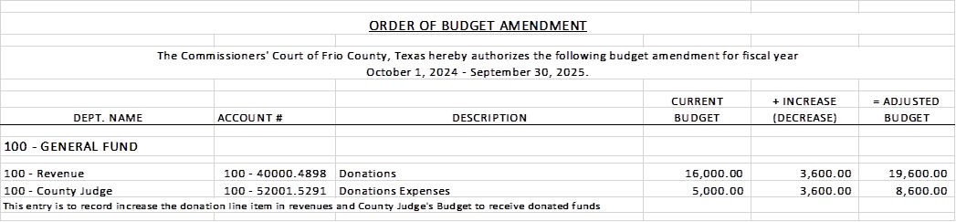

9.2 If the amendment is approved, consider/take action on signing order stating same.

**MOTION: COMMISSIONER MARTINEZ**

**SECOND: COMMISSIONER CANO**

**MOTION PASSES**

(10) Hon. Rochelle Camacho, Frio County Judge, requests:

10.1 Consider/take action on approving a Termination Agreement between Frio County and the Frio County Hospital District for the provision of medical transport services.

10.2 If the agreement is approved, consider/take action on approving a resolution authorizing Hon. Rochelle Camacho, Frio County Judge, to sign same on behalf of Frio County.

**MOTION: COMMISSIONER MARTINEZ**

**SECOND: JUDGE CAMACHO**

**MOTION PASSES**

**COMMISSIONER CANO AND COMISSIONER VELA VOTED AGAINST**

(11) Hon. Rochelle Camacho, Frio County Judge, requests:

Consider/take action to sign a Well Abandonment Form for the Evergreen Underground Water Conservation District for well number EUWCD-01081

**MOTION: COMMISSIONER MARTINEZ**

**SECOND: COMMISSIONER CANO**

**MOTION PASSES**

(12) Hon. Rochelle Camacho, Frio County Judge, requests:

12.1 Recess the Special called meeting reconvene in executive session pursuant to Texas Gov.’t Code 552.071 to meet with legal counsel of Allison, Bass & Magee, L.L.P. regarding the status of construction matters regarding the Camino Real Work Force Center with Sandoval Contracting, and the bridge construction project at CR 2410 and CR 3314 with ONO Contracting.

**MOTION TO BREAK INTO EXECUTIVE SESSION @ 3:57 PM**

**MOTION: COMMISSIONER MARTINEZ**

**SECOND: COMMISSIONER CARRIZALES**

**MOTION PASSES**

**MOTION TO RESUME INTO OPEN SESSION @ 4:39 PM**

**MOTION: COMMISSIONER MARTINEZ**

**SECOND: COMMISSIONER CARRIZALES**

**MOTION PASSES**

12.2 Consider/take action to pay part or all of the final invoice submitted by Sandoval Contracting.

**MOTION MADE THAT UPON RECEIPT OF A FINAL ACCOUNTING BY EACH SUBCONTRACTOR STILL OWED MONIES FOR WORK ON THE FRIO COUNTY COMMUNITY BUILDING PROJECT AND UPON APPROVAL OF THE FINAL ACCOUNTING BY THE ARCHITECT AND FRIO COUNTY LEGAL COUNSEL. FRIO COUNTY MOVES TO PAY, SAID SUBCONTRACTORS BY JOINT CHECK TO SANDOVAL AND THE SUBCONTRACTORS.AND THE CHECK WILL BE HANDED OVER AFTER A NOTARIZED RELEASE IS RECEIVED BY EACH SUBCONTRACTOR THAT HAS YET TO BE FULLY PAID INDIRECTLY, THAT ALL DEBTS TO THE COMMUNITY OUTBUILDING PROJECT ARE SATISFIED.SUBCONTRACTOR RESULTING FROM THEIR WORK ON THE FRIO COUNTY**

**MOTION: COMMISSIONER CARRIZALES**

**SECOND: COMMISSIONER CANO**

**MOTION PASSES**

(13) Hon. Danny Cano, Frio County Commissioner, Precinct No. 4, requests:

Consider/take action on posting notice in the Frio Nueces Current on Thursday, March 6, 2025, for one week pursuant to Texas Transportation Code Sec. 251.152.

**NOTICE FOR PUBLIC HEARING**

The Frio County Commissioners Court will conduct a Public Hearing regarding proposed parking restrictions along portions of County Roads 4600, 4601, 4602, 4603, 4604, and 4605, in the Hilltop Subdivision of Frio County, Texas. The meeting will be held during the special-called meeting of the Frio County Commissioners Court on Tuesday, March 25, 2025 at 3:00 p.m. at the Frio County Courtroom, 500 East San Antonio Street, Pearsall, Texas. The purpose of the public hearing is to present the proposed amended parking restrictions to the public and receive comments.

**MOTION: COMMISSIONER CANO**

**SECOND: COMMISSIONER MARTINEZ**

**MOTION PASSES**

(14) Hon. Danny Cano, Frio County Commissioner, Precinct No. 4, requests:

14.1 Recess the Special called meeting reconvene in executive session pursuant to Texas Gov.’t Code 552.071 to deliberate about personnel matters involving the Frio County Road and Bridge Administrator and other management issues at the Frio County Road and Bridge Department*.*

**MOTION TO GO INTO EXECUTIVE SESSION @ 4:46 PM**

**MOTION: COMMISSIONER CANO**

**SECOND: COMMISSIONER CARRIZALES**

**MOTION PASSES**

**MOTION TO RESUME OPEN SESSION @ 6:31 PM**

**MOTION: COMMISSIONER CARRIZALES**

**SECOND: COMMISSIONER CANO**

**MOTION PASSES**

14.2 Reconvene the special called meeting and consider/take action on reprimanding the county road administrator.

**motion after hearing the statements presented TODAY, I feel enough has been said on how this matter needs to be taken care of. Some of the proper departments were informed of the complaints and handled internal. I do not believe the situation will change for the record. I make a motion to reprimand administrator with a no confidence of the administrative performance and duties of our county road and bridge administrator take action, suspension for 3 weeks with pay until further investigation is completed.**

**MOTION: COMMISSIONER CANO**

**SECOND: COMMISSIONER VELA**

**MOTION DOES NOT PASS**

**APPOSED VOTES**

**COMMISSIONER MARITNEZ**

**COMMISSIONER CARRIZALES**

**JUDGE CAMACHO**

(15) Documents (resolutions, orders, contracts, etc.) to be signed.

(16) Allow bills payable

**TO INCLUDE PROPOSED UTILITY ACCOUNT**

**MOTION: COMMISSIONER CARRIZALES**

**SECOND: COMMISSIONER CANO**

**MOTION PASSES**

(17) Adjourn

**MOTION: COMMISSIONER CARRIZALES**

**SECOND: COMMISSIONER MARTINEZ**

**MOTION PASSES**